# CHAPTER 3. Capacity of All-Way Stop-Controlled Intersections

## 1. Introduction

In this chapter we will explore the models on which the HCM capacity analysis method for all-way stop-controlled (AWSC) intersections is based. We’ll start in section 2 with a discussion of how AWSC intersections operate in the field, particularly the interaction between drivers traveling through the intersection. In section 3, we’ll identify the important factors in this interaction that will help us to formulate models to predict the capacity of an intersection approach. The models that we will formulate in sections 4 and 5 are based on “simplified scenarios”, scenarios in which only the most important traffic and geometric factors are considered. By focusing only on these factors, you will develop a basic understanding of the operation of an AWSC intersection, one that can later be built upon as the more complex conditions found in the real world are considered.

You will study two such scenarios. The first scenario is based on the intersection of two one-lane one-way streets, while the second scenario is based on one lane approaches at a standard 4-leg intersection. In both scenarios, we assume through movements only (no turning movements) and a traffic stream consisting only of passenger cars. Finally, we assume that there are no pedestrians to impede the flow of automobile traffic.

You will see that the operation of an AWSC intersection is based primarily on the interactions between drivers, each driver having to make the decision: “when is it my turn to enter the intersection?” The higher the traffic flow rates, the more intense are these interactions, and the longer drivers must wait until it is their turn to enter the intersection.

You will build a computational engine in section 6, based on the second scenario described above. You can use the computational engine (in the form of a spreadsheet) to study the predictions of capacity that the model makes under a range of traffic flow conditions. These predictions will help you to understand when all-way stop control might be an effective control strategy and under what conditions other types of control should be considered. You will also see under what conditions the intersection approach will reach capacity.

A summary of the chapter is presented in Section 7. Section 8 presents a list of all terms and variables used in the chapter and provides a definition or description for each. A list of references is presented in section 9. A set of problems for you to test your understanding of this material is given in section 10; the solutions to the problems are given in section 11.

## 2. What Do We Observe in the Field?

An AWSC intersection is an intersection in which all approaches are controlled by stop signs. Each driver must stop when they reach the stop line and determine when it is safe for them to enter the intersection. Some localities are governed by the rule that the “driver on the right” has the right-of-way if several vehicles arrive at the intersection at the same time. But whatever the rule, it is the interaction between the drivers that determines how the intersection operates.

Since we are interested in predicting the capacity of an intersection approach, let’s consider what drivers see and do as they arrive at an AWSC intersection. If there are other vehicles on the approach, a driver waits in queue as the other vehicles are served. This time spent waiting in queue is part of the delay experienced by drivers. The other part of the delay is the time spent at the stop line. And, how long a driver waits at the stop line depends largely on whether there are other drivers waiting on the other approaches competing for their turn to enter the intersection.

If there are no other vehicles on any of the other intersection approaches, a driver enters the intersection just as soon as he or she stops and assesses that conditions are safe. If there is one other vehicle on the cross street, the drivers jointly decide who goes next and who must wait. And, if there are vehicles on all of the other approaches, this joint decision making process is even more complex and time consuming. What does this mean for the capacity of the intersection approaches? The more approaches that are occupied by waiting vehicles, the lower the rate of flow of departing vehicles on any of the approaches. Or, said another way, the higher the degree of conflict between drivers on the intersection approaches, the lower the capacity of any given approach.

Other factors also limit the capacity of an intersection approach, such as pedestrians crossing the street, turning vehicles that take extra time to complete their maneuvers, and heavy vehicles that are slower to accelerate than passenger cars. But while these factors are often present in the field, we will only consider simplified scenarios in which there are no pedestrians, only through movements, and only passenger cars in the traffic stream. This will help you to focus on basic principles as you develop an understanding of how an AWSC intersection operates and the factors that affect the capacity of its approaches.

[add pictures or videos to illustrate the basic operation]

One more point can be made about the flow of traffic at an AWSC intersection, particularly when traffic volumes are high and the intersection operates near capacity. When there is one lane on each approach, a rhythm develops in which vehicles on opposite approaches enter the intersection at the same time: Vehicles on the northbound and southbound approaches enter together, followed by vehicles on the eastbound and westbound approaches. This rhythm may be broken if a driver hesitates or if one vehicle makes a left turn, but it is common to observe this pattern of operation during peak periods.

## 3. Formulating the Model

We will use a queuing model to represent the traffic flow conditions on one approach of the AWSC intersection based on the conditions that we’ve observed in the field. This queuing model consists of the following parts:

* Vehicles arrive at the intersection in a random manner, with headways between vehicles following a negative exponential distribution.
* Vehicles are served one at a time at a rate that depends on the degree of conflict that they face.
* The degree of conflict can be represented by a set of distinct cases, each case based on the number of approaches that are occupied by waiting vehicles.
* During conditions of continuous queuing, each degree of conflict case has a defined headway between departing vehicles, called the saturation headway.

To illustrate these concepts, consider a case consisting of the sequence of events shown in Figure 1. The sequence begins with a queue of three vehicles on the approach of interest, called the subject approach. The first vehicle on the subject approach (vehicle 1, event 1) enters the intersection. In event 2, vehicle 2 moves to the stop line. Vehicle 2 enters the intersection in event 3, 3.9 seconds after vehicle 1 enters the intersection. The figure shows these three events in the sequence in which they occur, along with the clock time at which each event occurs.



Figure . Sequence of events for vehicles entering an AWSC intersection

For this case, the degree of conflict is low. The saturation headway for this case is given by:

$$h=clock time \left(event 3\right)-clock time \left(event 1\right)=3.9\sec{- 0.0\sec{= }}3.9 sec$$

Now consider a case that also starts with a queue of three vehicles on the subject approach but with one vehicle on one of the conflicting approaches of the cross street. The first vehicle on the subject approach enters the intersection (event 1, vehicle 1). In event 2, vehicle A, the vehicle on the conflicting approach, enters the intersection. In event 3, vehicle 2 enters the intersection. Figure 2 shows these three events in the sequence in which they occur, along with the clock time at which each event occurs.

The headway on the subject approach, the clock time between the departure of vehicles 1 and 2, is 5.8 sec. This is the saturation headway for this degree of conflict case.

$$h=clock time \left(event 3\right)-clock time \left(event 1\right)=5.8\sec{- 0.0\sec{=}}5.8 sec$$

In summary, this model for determining the capacity of one approach of an AWSC intersection is based on the following concepts:

* One approach, called the subject approach, is analyzed at a time.
* The headway between consecutive departing vehicles on the subject approach is called the departure headway; during periods of continuous queuing, the headway is called the saturation headway.
* The saturation headway depends on the degree of conflict experienced by drivers on the subject approach.

In the next section we’ll develop a scenario that implements this model formulation for the intersection of two one-way streets.



Figure . Sequence of events for vehicles entering an AWSC intersection

## 4. Scenario 1: Intersection of Two One-Way Streets

Let’s consider an intersection of two one-lane, one-way streets, with through movements only. We’ll call this Scenario 1. In this section, we’ll study the conditions on both approaches to the intersection and develop a model to predict the capacity of each approach. This capacity depends heavily on the volume of traffic on both approaches.

In this scenario, drivers on each approach face one of two cases. In the first case there are no vehicles on the conflicting approach and in the other case there is one or more vehicles on the conflicting approach. Research has shown that for the first case, the saturation headway between vehicles departing on the subject approach is 3.9 sec, if there is a continuous queue on this approach. For the other case, since the degree of conflict is higher, the saturation headway is also higher: 5.8 sec between departing vehicles. For reasons that we will discuss in section 5, we will call this Case 3.



Figure . Scenario 1: Two intersecting one-way streets

The mean departure headway between vehicles on the subject approach is thus a function of the saturation headway for each of the two cases, and the probability that each case will occur. From queuing theory, the probability or likelihood of not observing a vehicle on the conflicting approach is equal to one minus the degree of utilization (1-ρ) on that approach. For our analysis of AWSC intersections, the degree of utilization on the conflicting approach is the likelihood that there is a vehicle on that approach and is equal to the arrival flow rate divided by the maximum service rate, or, as more commonly used in traffic engineering, the volume-to-capacity ratio.

Mathematically, we can write the departure headway for vehicles on the subject approach (hd,sub) as the expected value of a bimodal distribution, with hs1 and hs3 as the saturation headways for each of the two modes.

Equation

where Xcon is the degree of utilization on the conflicting approach. As stated above, we can also think of the degree of utilization as the probability that a vehicle is present on that approach at any given time.

Let’s now consider our simplified scenario. For the two intersecting one-way streets (with NB and WB traffic only), the mean departure headway for each approach can be written as follows:

Equation

Equation

We can write Equation 2 and Equation 3 in a form which allows us to more directly calculate the departure headways on each approach. To do this, we must first note that X can be written as the product of the arrival rate λ and the departure headway hd. Another way of thinking about this formulation of X is as the product of the number of vehicles that arrive in the time period (and then converted to veh/sec)

and the time between departing vehicles, as shown in Equation 4 and Equation 5.

Equation

Equation

Substituting Equation 4 into Equation 2 and Equation 5 into Equation 3 we get expressions from which we can directly compute the departure headways for the NB and WB approaches.

Equation

Equation

More generally, the departure headway for the subject approach can be written:

Equation

Since hs1 = 3.9 sec and hs3 = 5.8 sec, Equation 8 can be simplified to:

Equation

Equation

Equation

And, for this example with NB and WB traffic, the departure headways can be written as:

Equation

Equation

### **Example Calculation 1**

Let’s consider an example in which the volumes are 300 veh/hr on the NB approach and 200 veh/hr on the WB approach. We are also given the saturation headways for the two degree of conflict cases:

$$h_{s1}=3.9 sec/veh$$

$$h_{s3}=5.8 sec/veh$$

What is the mean departure headway for vehicles on each approach and what is the degree of utilization X for each approach? The three steps to solve this problem are shown below.

Step 1. Calculate λ, the flow rate in veh/sec, based on the volumes given in veh/hr.

$$λ_{NB}= \frac{300 veh/hr}{3600 sec/hr}=.083 veh/sec$$

$$λ_{WB}= \frac{200 veh/hr}{3600 sec/hr}=.056 veh/sec$$

Step 2. Calculate the departure headway for each approach, hd.

For the NB approach, using Equation 12:

$$h_{d,NB}= \frac{3.9+{7.41λ}_{WB}}{1-{3.61λ}_{NB}λ_{WB}}$$

$$h_{d,NB}= \frac{3.9+7.41(0.056 veh/sec)}{1-3.61(0.083 veh/sec)(0.056 veh/sec)}$$

$$h_{d,NB}=4.4 sec$$

For the WB approach, using Equation 13:

$$h_{d,WB}= \frac{3.9+{7.41λ}_{NB}}{1-{3.61λ}_{NB}λ_{WB}}$$

$$h_{d,WB}= \frac{3.9+7.41(0.83 veh/sec)}{1-3.61(0.083 veh/sec)(0.056 veh/sec)}$$

$$h_{d,WB}=4.6 sec$$

For the NB approach, the mean headway for departing vehicles is 4.4 sec while for the WB approach it is 4.6 sec.

Step 3. Calculate X, the degree of utilization for each approach, using Equation 4 and Equation 5.

For the NB approach:

$$X_{NB}=λ_{NB}h_{d,NB}$$

$$X_{NB}=\left(.083 veh/sec\right)\left(4.4 sec/veh\right)= .37$$

For the WB approach:

$$X_{WB}=λ_{WB}h_{d,WB}$$

$$X_{WB}=\left(.056 veh/sec\right)\left(4.6 sec/veh\right)= .26$$

The degree of utilization is 0.365 for the NB approach and 0.255 for the WB approach, both well below 1.0. There is sufficient capacity to serve the given demand. Note that these values also represent the proportion of time that we are likely to see a vehicle on each of these two approaches.

### **Example Calculation 2**

Let’s consider another example in which the volumes are 300 veh/hr on the NB approach and 900 veh/hr on the WB approach. What are the mean departure headway and the degree of utilization for each approach?

Step 1. Calculate λ, the flow rate in veh/sec based on the volumes given in veh/hr.

$$λ_{NB}= \frac{300}{3600}=.083 veh/sec$$

$$λ_{WB}= \frac{900}{3600}=.250 veh/sec$$

Step 2. Calculate departure headway for each approach, hd.

For the NB approach, using Equation 12:

$$h_{d,NB}= \frac{3.9+{7.41λ}_{WB}}{1-{3.61λ}_{NB}λ_{WB}}$$

$$h_{d,NB}= \frac{3.9+7.41(0.250 veh/sec)}{1-3.61(0.083 veh/sec)(.250 veh/sec)}$$

$$h_{d,NB}=6.2 sec/veh$$

For the WB approach, using Equation 13:

$$h_{d,WB}= \frac{3.9+{7.41λ}_{NB}}{1-{3.61λ}_{NB}λ_{WB}}$$

$$h_{d,WB}= \frac{3.9+7.41(0.083 veh/sec)}{1-3.61(0.083 veh/sec)(0.250 veh/sec)}$$

$$h_{d,WB}=4.9 sec/veh$$

Step 3. Calculate X, the degree of utilization for each approach, using Equation 4 and Equation 5.

For the NB approach:

$$X_{NB}=λ_{NB}h_{d,NB}$$

$$X_{NB}=\left(.083 veh/sec\right)\left(6.2 sec/veh\right)= .52$$

For the WB approach:

$$X_{WB}=λ_{WB}h_{d,WB}$$

$$X_{WB}=\left(.250 veh/sec\right)\left(4.9 sec/veh\right)= 1.22$$

When we examine these results, a problem arises. The bi-valued distribution for the saturation headways (Cases 1 and 3) has two values: 3.9 sec and 5.8 sec. The departure headway that is computed must be between these two values. For the NB approach it is not. More evidence of the problem arises when we examine the degree of saturation for the WB approach, which we have calculated to be 1.22. While not directly stated, we have implicitly assumed that X is less than 1.0. Clearly this assumption has been violated. We will explore this issue further in Example Calculation 3.

### **Example Calculation 3**

Let’s again consider an example in which the volume on the NB approach is 300 veh/hr. But this time we’ll investigate a range of flow rates on the WB approach. And we’ll ask the following questions:

* What is the capacity of the WB approach?
* How does the degree of utilization on the NB approach vary as the volume on the WB approach increases?
* What is the degree of utilization on the NB approach when the WB approach reaches capacity?

Table 1 shows the results of the calculations for a range of volumes on the WB approach. We note that as the volume on the WB approach increases, the departure headway on the NB approach also increases as NB vehicles are more likely to see one or more vehicles on the WB approach, further increasing the degree of conflict.

Table . Variation of X and h with flow rate

|  |  |  |  |  |
| --- | --- | --- | --- | --- |
| **vWB** | **hNB** | **hWB** | **XNB** | **XWB** |
| 0 | 3.9 | 4.5 | 0.33 | 0.00 |
| 50 | 4.0 | 4.5 | 0.33 | 0.06 |
| 100 | 4.1 | 4.6 | 0.35 | 0.13 |
| 150 | 4.3 | 4.6 | 0.36 | 0.19 |
| 200 | 4.4 | 4.6 | 0.37 | 0.26 |
| 250 | 4.5 | 4.6 | 0.38 | 0.32 |
| 300 | 4.6 | 4.6 | 0.39 | 0.39 |
| 350 | 4.8 | 4.7 | 0.40 | 0.45 |
| 400 | 4.9 | 4.7 | 0.41 | 0.52 |
| 450 | 5.0 | 4.7 | 0.42 | 0.59 |
| 500 | 5.1 | 4.7 | 0.43 | 0.65 |
| 550 | 5.3 | 4.7 | 0.44 | 0.72 |
| 600 | 5.4 | 4.8 | 0.45 | 0.79 |
| 650 | 5.5 | 4.8 | 0.46 | 0.86 |
| 700 | 5.7 | 4.8 | 0.47 | 0.93 |
| 750 | 5.8 | 4.8 | 0.48 | 1.00 |
| 800 | 5.9 | 4.8 | 0.50 | 1.08 |
| 850 | 6.1 | 4.9 | 0.51 | 1.15 |
| 900 | 6.2 | 4.9 | 0.52 | 1.22 |

When X reaches 1.0 on the WB approach, that approach has reached capacity. Even if the demand increases, the volume that is served will never exceed 750 veh/hr. Thus for these conditions (NB approach volume of 300 veh/hr), the capacity of the WB approach is 750 veh/hr.

XNB increases somewhat as the WB volume increases, from 0.33 to 0.52. XNB is 0.48 when the WB approach reaches capacity.

Figure 4 shows the change in the departure headway on both the NB and WB approaches as the volume on the WB approach increases.



Figure . Variation of h with WB approach volume

Figure 5 shows the change in the degree of saturation on both approaches as the volume on the WB approach increases.



Figure . Variation of X with WB approach volume

## 5. Scenario 2: Four-Leg Intersection with Single Lane Approaches

Let’s now consider the second simplified scenario, an intersection with four approaches, and one lane on each approach. Again, we will assume no turning movements; all vehicles proceed straight through the intersection. Here are some questions for you to consider:

* What are the cases that completely describe the degree of conflict experienced by drivers on a given approach?
* What is the saturation headway for each degree of conflict case?
* What is the probability that each degree of conflict case will occur for a given set of traffic flow conditions?

Figure 6 shows the way in which each approach is defined. Note that the NB approach is shown as the subject approach, but that is only for example purposes. As described previously, each approach is analyzed separately and so becomes the subject approach when it is being analyzed.



Figure . Nomenclature for AWSC intersection approaches

Let’s consider the degree of conflict cases. There are five cases as shown in Figure 7, including Case 1 and Case 3 that we considered earlier in the first simplified scenario in section 4. These five cases define the range of conditions that a subject approach vehicle will face:

* Case 1: No vehicles on any of the opposing or conflicting approaches.
* Case 2: A vehicle on the opposing approach, but not on either of the conflicting approaches.
* Case 3: A vehicle on one of the conflicting approaches but not on the opposing approach.
* Case 4: A vehicle on two of the other approaches.
* Case 5: A vehicle on all three approaches.

Each of these cases results in an increasing degree of conflict, from Case 1 to Case 5. Similarly, the saturation headway increases as the degree of conflict increases. It simply takes longer to wait your turn and enter the intersection as the number of vehicles on the opposing and conflicting approaches increases.

The probability that each of these cases will occur is given by the products of the degrees of saturation on each of the three approaches faced by the subject approach driver. For case 1, for example, the case where a subject vehicle does not face any other vehicles, the probability of occurrence is given by Equation 14. Each term in the equation is the probability that a vehicle is not present on one of the three approaches. The product of these terms is the joint probability that no vehicles are present on any of the other approaches.



Figure . Five degree of conflict cases for Scenario 2

Equation

Based on research, the saturation headway for each degree of conflict case is given in Table 2.

Table . Saturation headways for degree of conflict cases

|  |  |  |
| --- | --- | --- |
| **Degree of conflict case** | **Number of vehicles faced by subject approach vehicle** | **Saturation headway (sec)** |
| 1 | 0 | 3.9 |
| 2 | 1 | 4.7 |
| 3 | 1 | 5.8 |
| 4 | 2 | 7.0 |
| 5 | 3 | 9.6 |

The expected value of the departure headway hd on the subject approach is thus the sum of the products of the probability of the occurrence of each degree of conflict case and the saturation headway for that case. This expected value is given by Equation 15.

Equation

where P[Ci] is the probability that case i will occur and hsi is the saturation headway for case i. But in contrast to Scenario 1, we can’t solve directly for hd for each approach. The interdependencies of the traffic flow on the approaches are just too great. So we must use an iterative process, calculating the departure headway for each approach, and recalculating it until the values from one iteration do not change substantially from the values calculated in the previous iteration. This process is too complex to be done manually; a computational engine is required.

To begin this process, let’s lay out the six computational steps involved. These steps are completed concurrently for each approach.

Step 1. Convert the volume v in veh/hr to the flow rate λ in veh/sec.

Equation

Step 2. Calculate the degree of utilization.

Equation

Step 3. Compute the probability of each degree of conflict case.

Equation

Equation

Equation

Equation

Equation

Step 4. Compute the departure headway.

Equation

Step 5. Check if the value of hd in the current iteration has not changed by more than the convergence criterion (.001) from its value in the previous iteration. If the convergence criterion is met, as described in Equation 24, then proceed to step 6. If not, return to step 2 and recalculate X for each approach based on the current value of hd for that approach.

Equation

Step 6. Compute the capacity. The capacity on the subject approach is computed under the assumption that the flows on the other approaches remain constant, while the flow on the subject approach is increased until Xsub reaches 1.0. When this occurs, the volume on the subject approach is said to be its capacity.

This process is summarized in Figure 8.



Figure . Calculation steps for Scenario 2

To learn more about this model and to see the results that it produces under various conditions, we need to build a computational engine. We will build this engine in the next section of this chapter.

## 6. Building a Computational Engine and Exploring the Model

Let’s now set up the computational engine and explore what the model predicts under a variety of traffic flow conditions. The computational engine, to be built using an Excel spreadsheet, should satisfy the following requirements:

* Accepts the volumes (v, veh/hr) on each approach as inputs.
* Computes flow rates (λ, veh/sec) for each approach.
* Computes XS, XO, XCL, and XCR for each approach iteratively.
* Computes P[Ci] for each of the five degree of conflict cases for each approach iteratively.
* Computes the departure headway hd for each approach iteratively until convergence is reached.

Figure 9 shows the computational engine template. The input volumes are entered in row 4 for each approach. The flow rates in veh/sec are calculated in row 7. The degree of utilization for each subject approach is calculated in row 10. The degrees of utilization for the other approaches are calculated in rows 11 through 13. The probability of occurrence for each degree of conflict case is calculated in rows 16 through 20. As a check, the sum of these probabilities is shown in row 21 and must equal one. The resulting departure headway and degree of utilization are calculated in rows 24 and 25, respectively. Note that the value of X shown in row 10 is constrained to be equal to or less than one, while the value shown in row 25 is not. This is because the value in row 10 is also considered to be the probability that a vehicle is present on the approach and this value must always be less than or equal to one.

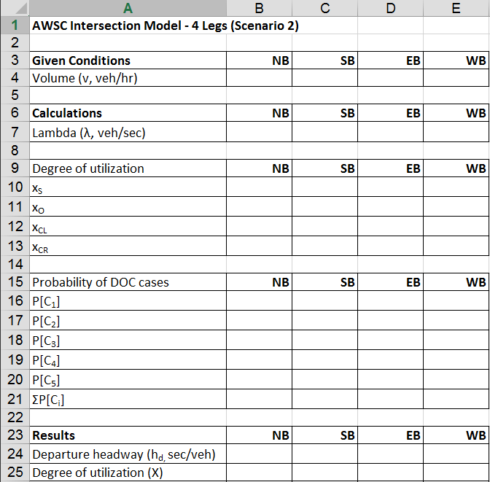

Figure . AWSC intersection computational engine template

To assist you in constructing the computational engine, Table 3 shows the formulas that are used for column B in the template shown in Figure 9.

Table . Example formulas for NB approach (column B)

|  |  |
| --- | --- |
| **Row** | **Formula** |
| 7 | =B4/3600 |
| 10 | =IF(B25>1,1,B25) |
| 11 | =IF(C25>1,1,C25) |
| 12 | =IF(D25>1,1,D25) |
| 13 | =IF(E25>1,1,E25) |
| 16 | =(1-B11)*(1-B12)*(1-B13) |
| 17 | =B11*(1-B12)*(1-B13) |
| 18 | =(1-B11)*B12*(1-B13)+(1-B11)*(1-B12)*B13 |
| 19 | =B11*(1-B12)*B13+B11*B12*(1-B13)+(1-B11)*B12*B13 |
| 20 | =B11*B12*B13 |
| 21 | =SUM(B16:B20) |
| 24 | =B24 |
| 25 | =B24*B7 |

### **Example Calculation 4.**

Consider an AWSC intersection at which the volumes on each approach are 300 veh/hr. Let’s run several tests to validate that our computational engine is working correctly.

Test 1. The first test is to make sure that the sum of the probabilities for the degree of conflict cases equals one. Examining the results shown in row 21 in Figure 10, we see that this is true.

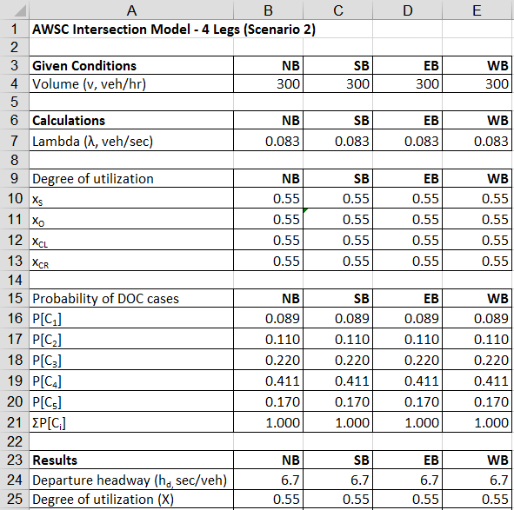

Figure . Example Calculation 4, Test 1

Test 2. The second test is to make sure that the boundary condition represented by each of the five degree of conflict cases is accurately represented.

With traffic present only on one approach, the departure headway for the subject approach should be equal to the saturation headway for Case 1, or 3.9 sec. Examining the result in row 24, Figure 11, we confirm that this is true.

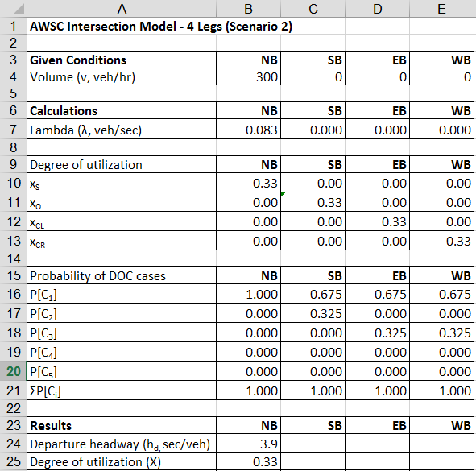

Figure . Example Calculation 4, Test 2, Case 1

With traffic on the NB and SB approaches only, the departure headway for the two approaches should equal the saturation headway for Case 2, or 4.7 sec. We confirm that this is true by examining the results in row 24, Figure 12.

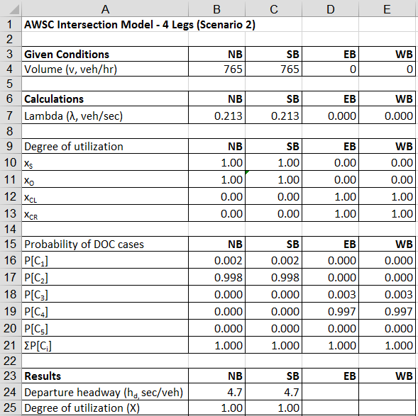

Figure . Example Calculation 4, Test 2, Case 2

With traffic on the NB and EB approaches only, the departure headway for the two approaches should equal the saturation headway for Case 3, or 5.8 sec. We confirm that this is true by examining the results in row 24, Figure 13.

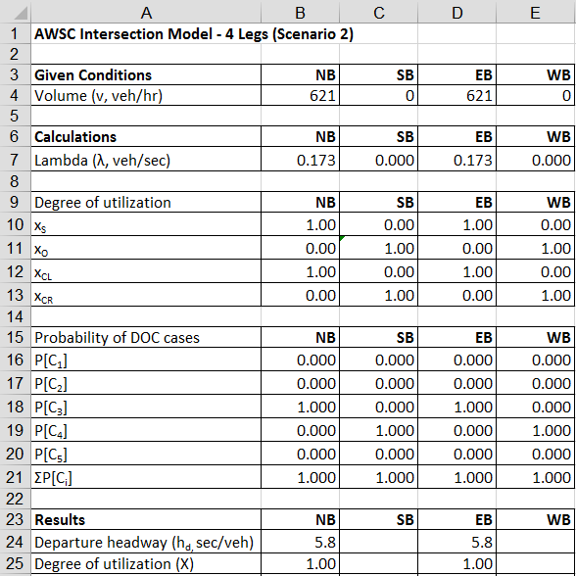

Figure . Example Calculation 4, Test 2, Case 3

With traffic on three approaches, the departure headway for each approach should equal the saturation headway for Case 4, or 7.0 sec, as shown in row 24, Figure 14.

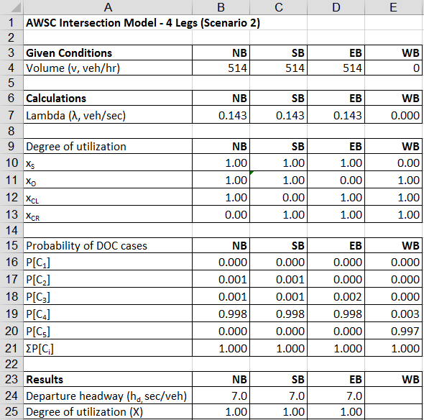

Figure . Example Calculation 4, Test 2, Case 4

For Case 5, with traffic on all four approaches, the departure headway for each approach should equal the saturation headway for this case, or 9.6 sec, as shown in row 24, Figure 15.

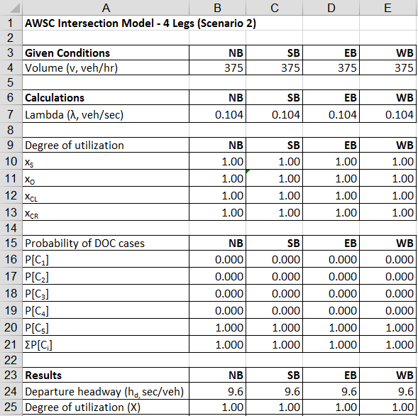

Figure . Example Calculation 4, Test 2, Case 5

### Example Calculation 5

Assume an intersection with 300 veh/hr on each approach. Use the spreadsheet to determine the capacity of the NB approach.

Figure 16 shows the results when the volume on each approach is 300 veh/hr.

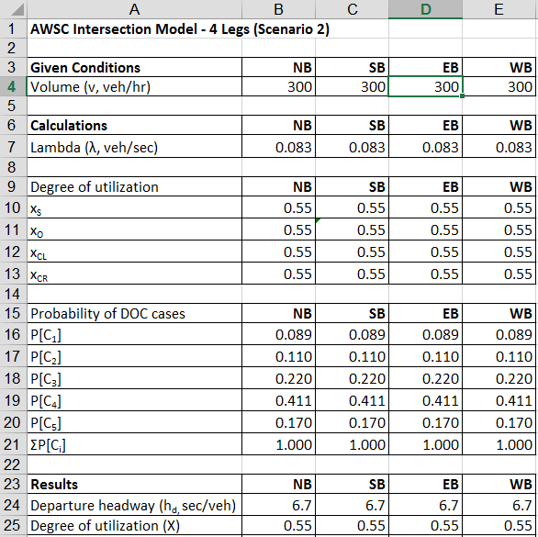

Figure . Initial results for Example Calculation 5

To determine the capacity of the NB approach, the volume on that approach is increased until XNB reaches 1.0. This condition occurs when the volume on the NB approach is 494 veh/hr. Thus the capacity for this approach, under these traffic flow conditions, is 494 veh/hr. Figure 17 shows this result.

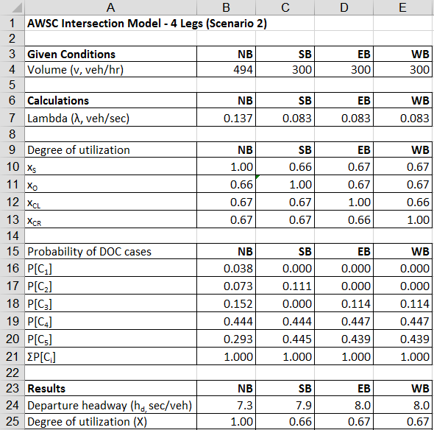

Figure . Final results for Example Calculation 5 showing capacity for NB approach

*Example Calculation 6*

Consider the second part of Example Calculation 5, in which the NB volume was 494 veh/hr and the volume on the other three approaches was 300 veh/hr. We determined that the capacity of the NB approach is 494 veh/hr since the degree of utilization was determined to be 1.0, as shown in Figure 18.

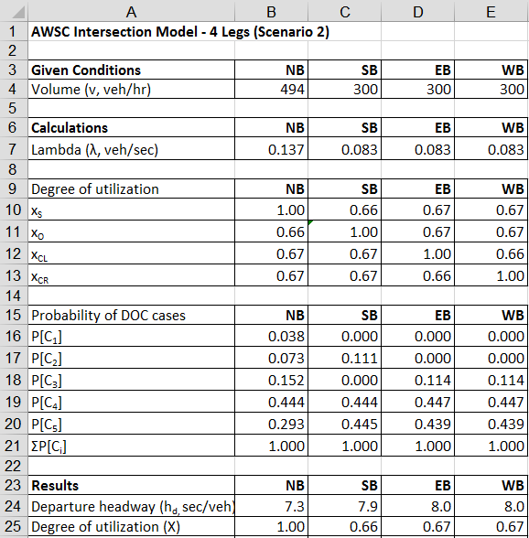

Figure . Initial results for Example Calculation 6

But what happens if the NB volume is increased to 600 veh/hr, as shown in Figure 19? The value of the degree of utilization in row 10 for the NB approach is 1.00. This is the maximum value for X in rows 10 through 13, since here X is viewed as the probability that a given degree of conflict case will occur. And, this value can’t exceed 1.0. However, X in row 25 is equal to 1.22. This is the true degree of utilization and the value implies that the demand exceeds the capacity of the approach. Even though the demand on the NB approach is 600 veh/hr, only 494 vehicles will be served during the hour. A more complete analysis of these conditions would consider a second time period in which the demand that wasn’t served during the first time period would be analyzed.

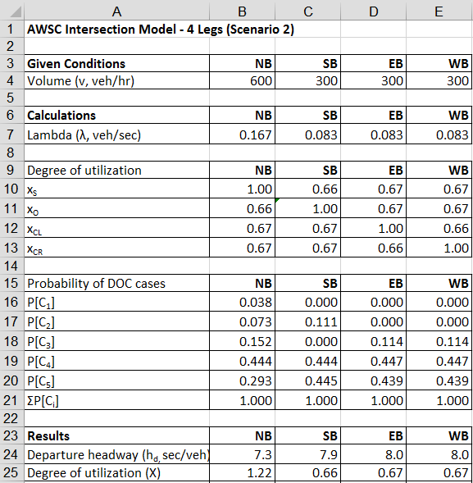

Figure . Final results for Example Calculation 6

## 7. Summary

In this chapter we explored the models on which the HCM capacity analysis method for AWSC intersections is based. We reviewed how an AWSC intersection operates in the field, and the factors on which models to predict the capacity of an intersection approach could be based. In developing the models we used the concept of the simplified scenario, in which only the most important traffic and geometric factors are considered. By focusing only on these factors, you developed a basic understanding of the operation of an AWSC intersection, one that can be later built upon as the more complex conditions found in the real world are considered.

You studied two such scenarios. The first scenario was based on the intersection of two one-lane one-way streets, while the second scenario was based on one lane approaches at a standard 4-leg intersection. In both scenarios, we assumed through movements only (no turning movements), a traffic stream consisting only of passenger cars, and no pedestrians to impede the flow of automobile traffic. You learned that the operation of an AWSC intersection is based primarily on the interactions between drivers, each driver having to make the decision: “when is it my turn to enter the intersection?” The higher the traffic flow rates, the more intense are these interactions, and the longer drivers must wait until it is their turn.

## 8. Glossary

Table . Terms used in this chapter

|  |  |
| --- | --- |
| **Term** | **Definition** |
| Capacity | HCM: “Maximum number of vehicles that can pass a given point during a specified period under prevailing roadway, traffic, and control conditions.” |
| Departure headway | The time between the departures of two consecutive vehicles on one approach of an AWSC intersection. |
| Saturation headway | The time between the departures of two consecutive vehicles on one approach of an AWSC intersection during a period of continuous queuing on that approach. |
| Subject approach | The approach currently being analyzed. |
| Opposing approach | The approach opposite the subject approach. |
| Conflicting approach | The approach or approaches on the cross street from the perspective of the subject approach. |
| Degree of utilization | HCM: “The probability of finding at least one vehicle on [an] approach.” |

Table . Variables used in this chapter

|  |  |  |
| --- | --- | --- |
| **Variable** | **Description** | **Units** |
| hd | Departure headway | sec/veh |
| his | Saturation headway for degree of conflict case i | sec/veh |
| P[Ci] | Probability of degree of conflict case i | - |
| v | Arrival volume | veh/hr |
| X | Degree of utilization | - |
| λ | Arrival flow rate | veh/sec |

## 9. References

Hebert studied the headways between vehicles for two conditions at several AWSC intersections in Chicago in 1963. His work formed the basis for Richardson, who developed the initial formulations for what are described here as Scenarios 1 and 2. Kyte and others extended Richardson’s model for 4-leg intersections and, through a national study of AWSC intersections, delineated five degree of conflict cases and measured the saturation headway for each case. The work of Kyte and others is the basis for the HCM AWSC intersection methodology.

Hebert, J. A Study of Four-Way Stop-Controlled Intersection Capacities. In Highway Research Record 27, Highway Research Board, Washington, D.C., 1963.

Richardson, A.J. A Delay Model for Multiway Stop-Sign Intersections. In Transportation Research Record 1112, Transportation Research Board, National Research Council, Washington, D.C., 1987, pp 107-114.

Kyte, M., Z. Tian, Z. Mir, Z. Hameedmansoor, W. Kittelson, M. Vandehey, B. Robinson, W. Brilon, L. Bondzio, N. Wu, and R. Troutbeck. NCHRP Web Document 6: Capacity and Level of Service at Unsignalized Intersections: Final Report, Vol 2--All-Way Stop-Controlled Intersections.

Transportation Research Board, National Research Council, Washington, D.C., April 1996.

Kyte, M., Z. Tian, J. Kuhn, H. Poffenroth, M. Butorac, and B. Robertson. Saturation Headways at Stop-Controlled Intersections. In Transportation Research Record 1457, Transportation Research Board, National Research Council, Washington, D.C., 1994, pp 111-117.

## 10. Problems

Problem 1. What does the term "degree of conflict" mean?

Problem 2. Describe the probability of occurrence for case 2 and case 5.

Problem 3. Define the term "departure headway".

Problem 4. Describe how you would compute the capacity of one approach of an AWSC intersection with four legs using the spreadsheet computational engine. Construct an example to illustrate this calculation.

Problem 5. One of the best methods of studying the operation of an AWSC intersection is through field observation. Locate a suitable AWSC intersection and observe it for a period of 30 minutes during a peak flow period. Answer the following questions based on your observations:

* Are there continuous queues on any of the approaches?
* During these periods of continuous queuing, do you observe a particular order of vehicle departures from each stop line into the intersection?
* What is your estimate of the mean headway between the consecutive departures of vehicles on one of the approaches? Base your estimate on a sample of ten headways that you record.
* What factors do you think affect this mean value?
* What other observations of interest did you make?

Problem 6. The worksheet given in Figure 20 shows the results of an analysis of an AWSC intersection using the method for Scenario 2. After you have studied this worksheet, identify whether the following statements are true or not, based on the data presented in the worksheet. For the statements that you believe to be true, provide a brief justification to support your choice(s).

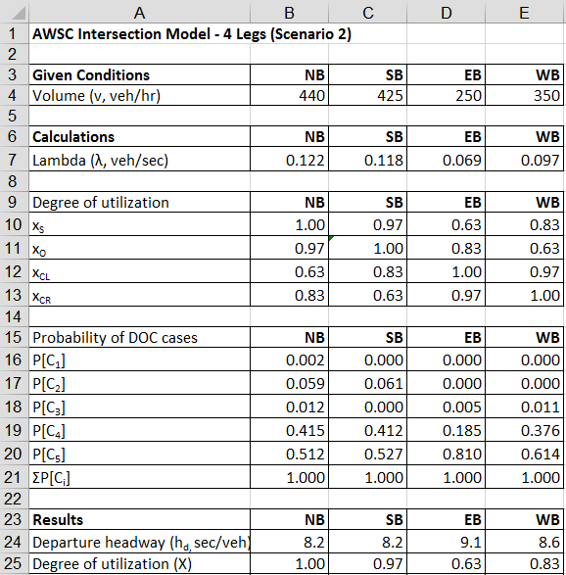

Figure . Problem 6

a. The capacity of the NB approach is 440 vehicles per hour.

b. The likelihood of an EB vehicle encountering no vehicle on the westbound approach is 0.166.

Problem 7. Consider an AWSC intersection with four approaches. What results are predicted when the volumes on each approach are set to 500 veh/hr? Describe what you would observe in the field for these conditions.

Problem 8. Consider an AWSC intersection with four approaches. Suppose the NB volume is 500 veh/hr and the volumes on the other approaches are zero. What is the capacity of the NB approach?

Problem 9. What is the condition (degree of conflict case) at which the intersection volume is maximum? Hint: Calculate the maximum volumes for each approach for each degree of conflict case.

Problem 10. Given a flow rate of 300 veh/hr on the NB approach for a two-leg AWSC intersection. How does X vary with volume on WB approach?

Problem 11. The worksheet in Figure 21 shows the results of an analysis of an AWSC intersection using the method of Scenario 2. After you have studied this worksheet, answer the following questions based on the traffic conditions shown for this intersection; provide brief justifications to support your answers.

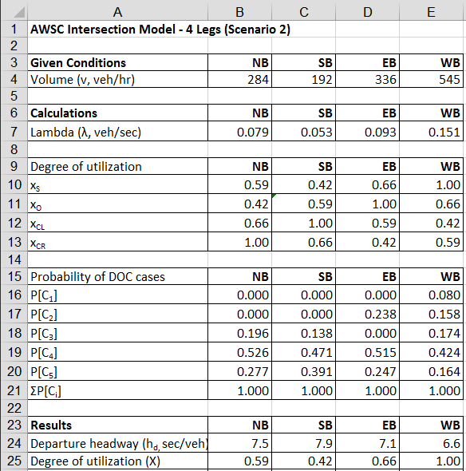

Figure . Problem 11

a. Why does the ΣP(Ci) = 1 for each approach?

b. If an approach is operating at capacity, what should be the product of the volume and the departure headway?

c. If a vehicle is on the SB approach, what is the probability of a vehicle being on the NB approach, with no vehicles present on the EB or WB approaches?

d. Would you agree that the capacity of the WB approach is 545 vehicles per hour?

e. Would you agree that the capacity of the SB approach is 458 vehicles per hour?

f. Is the capacity of the EB approach is greater than or less than 336 vehicles per hour?

Problem 12. An intersection currently has the following volumes. It is expected that traffic on all legs would increase at 4 per cent per year. How long would it take for the intersection to be become congested. Describe the operation of the intersection at this stage.

## 11. Problem Solutions

Problem 1. What does the term "degree of conflict" mean?

Solution: Degree of conflict refers to the number of approaches on which there are vehicles that conflict with the vehicle on the subject approach.

Problem 2. Describe the probability of occurrence for Case 2 and Case 5.

Solution: The degree of utilization is the probability of finding at least one vehicle on an approach. The probability of Case 2 occurring is the joint probability of finding a vehicle on the opposing approach and of finding no vehicle on the two conflicting approaches. The probability of Case 5 occurring is the joint probability of finding vehicles on the opposing and conflicting approaches.

Problem 3. Define the term "departure headway".

Solution: The departure headway is the time between the departures of two consecutive vehicles on one approach of an AWSC intersection.

Problem 4. Describe how you would compute the capacity of one approach of an AWSC intersection with four legs using the spreadsheet computational engine. Construct an example to illustrate this calculation.

Solution:

To compute the capacity of one approach, increase the volume on that approach until X equals 1.0 while maintaining the given conditions on the other approaches. Figure 22 shows the initial conditions with flow rates of 200 veh/hr on each approach. Figure 23 shows the variation of XNB as volumes on the NB approach are increased. Based on this analysis, we can conclude that the capacity of the NB approach is 629 veh/hr since this is the point at which XNB reaches 1.0.

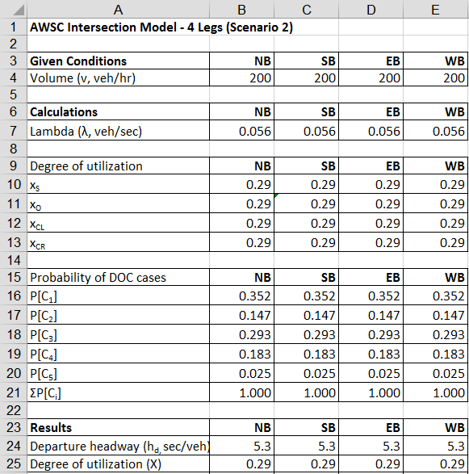

Figure . Problem 1



Figure . Variation of X with NB volume, Problem 1

Problem 5. One of the best methods of studying the operation of an AWSC intersection is through field observation. Locate a suitable AWSC intersection and observe it for a period of 30 minutes during a peak flow period. Answer the following questions based on your observations:

* Are there continuous queues on any of the approaches?
* During these periods of continuous queuing, do you observe a particular order of vehicle departures from each stop line into the intersection?
* What is the mean headway between the consecutive departures of vehicles on one approach? Base your answer on a sample of ten headways that you record.
* What factors do you think affect the value of this headway?
* What other observations of interest did you make?

Problem 6. The worksheet shown in Figure 20 shows the results of an analysis of an AWSC intersection using Scenario 2. After you have studied this worksheet, identify any or all of the following statements are true or not, based on the data presented in the worksheet. For the statements that you believe to be true, provide a brief justification to support your choice(s).



Figure

a. The capacity of the NB approach is 440 vehicles per hour.

b. The likelihood of an EB vehicle encountering no vehicle on the westbound approach is 0.166.

Solution:

a. True. X for the NB approach is 1.0. This means that the flow rate (440 veh/hr) is the capacity on this approach under these conditions.

b. True. The probability of observing a WB vehicle is .834. The probability of not observing a WB vehicle is 1-.834, or .166.

Problem 7. Consider an AWSC intersection with four approaches. What results are predicted when the volumes on each approach are set to 500 veh/hr? Describe what you would observe in the field for these conditions?

Solution: Figure 25 shows the predicted results. The volume on each approach exceeds the capacity of the approach, as X > 1.0 (as per row 25). In the field, we would observe continuous queuing on each approach for the duration of the study period, and increasing queues while this condition exists.

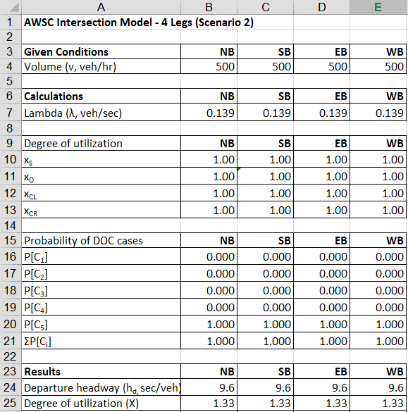

Figure . Problem 7 results

Problem 8. Consider an AWSC intersection with four approaches. Suppose the NB volume is 500 veh/hr and the volumes on the other approaches are zero. What is the capacity of the NB approach?

Solution: The capacity of the NB approach is 923 veh/hr. The departure headway is 3.9 sec/veh. This is determined by increasing the NB volume until XNB = 1.0, as shown in Figure 26. [Note: should we say that it is also 3600/3.9?]

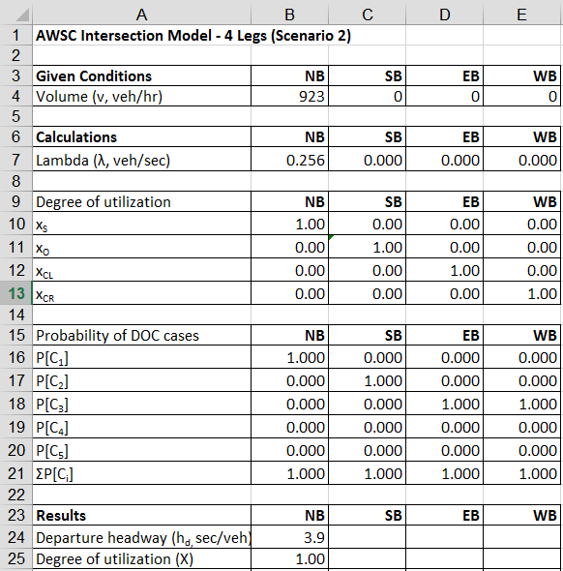

Figure . Problem 8 results

Problem 9. What is the condition (degree of conflict case) at which the intersection volume is maximum?

Solution: Table 6 shows the maximum flow for each approach for each of the five degree of conflict cases. The condition at which the intersection flow is a maximum occurs when there are vehicles on three approaches, with no flow on the fourth approach. This is degree of conflict Case 4 when the intersection volume is 1542 veh/hr. However, the intersection volumes for Cases 2 and 5 are close to this maximum value. All three cases have intersection volumes of 1500 veh/hr or higher, and are within 3 percent of each other.

Table . Intersection volumes, degree of conflict cases

|  |  |  |  |  |  |
| --- | --- | --- | --- | --- | --- |
| **Degree of conflict case** | **Volumes (veh/hr)** | | | | |
| **Subject approach** | **Opposing approach** | **Conflicting approach-left** | **Conflicting approach-right** | **Intersection** |
| 1 | 923 |  |  |  | 923 |
| 2 | 766 | 766 |  |  | 1532 |
| 3 | 621 |  | 621 |  | 1242 |
| 4 | 514 | 514 | 514 |  | 1542 |
| 5 | 375 | 375 | 375 | 375 | 1500 |

Problem 10. Given a flow rate of 300 veh/hr on the NB approach for a two-leg AWSC intersection. How does X vary with volume on WB approach?

Solution: Figure 27 shows the results. It should be noted that the models for Scenarios 1 and 2 yield the same results, as we would expect. Simply put, X increases as volume increases. The higher the demand, the higher the X on that approach.



Figure . Variation of X

Problem 11. The worksheet shown in Figure 28 shows the results of an analysis of an AWSC intersection using the method of Scenario 2. After you have studied this worksheet, answer the following questions based on the traffic conditions shown for this intersection; provide brief justifications to support your answers.



Figure

a. Why does the ΣP(Ci) = 1 for each approach?

Solution: Because Cases 1 through 5 represent all possible conditions a driver on a given approach may face.

b. If an approach is operating at capacity, what should be the product of the flow rate and the departure headway?

Solution: Capacity flow implies that there is a continuous queue and that the maximum number of vehicles are entering the intersection during the hour. Since the headway between vehicles during continuous queuing is not just the departure headway but the saturation headway, the product of the flow rate and the departure headway is 3600 sec.

c. If a vehicle is on the SB approach, what is the probability of a vehicle being on the NB approach, with no vehicles present on the EB or WB approaches?

Solution: This condition is represented by Case 2. For these conditions, P[C2] = 0.

d. Would you agree that the capacity of the WB approach is 545 veh/hr?

Solution: Yes, since X = 1.0 for the WB approach.

e. Would you agree that the capacity of the SB approach is 458 veh/hr?

Solution: No, because X < 1.0 for the SB approach. Because of the interaction with the other approaches, we must determine capacity by increasing the volume on the SB approach until X = 1.0

f. Is the capacity of the eastbound approach is greater than or less than 336 veh/hr?

Solution: Greater, since XEB = 0.66. [note: …and to have a higher X this volume on this approach must be increased.]

Problem 12. An intersection currently has the following volumes. It is expected that traffic on all legs would increase at 4 per cent per year. How long would it take for the intersection to be become congested. Describe the operation of the intersection at this stage.

Solution: [to be added]